How to Increase Sales Fast
Proven Strategies for Startups, Freelancers & Small Businesses
SEO-Reviewed Draft | Primary Keyword: “increase sales fast”

Meta Title: How to Increase Sales Fast: Proven Strategies for Startups, Freelancers & Small Businesses
Meta Description: Want to increase sales fast? Discover proven growth strategies for startups, freelancers & small businesses — real techniques, no fluff. Read now.

If you’ve Googled “how to increase sales fast,” you’ve probably already read ten articles telling you to “build trust” and “understand your customer’s needs.” True, but useless. You already know that — what you actually need is real ways to boost sales fast, something you can do this week that moves the needle.
This guide skips the fluff. It’s broken down by exactly who you are — because what works for a freelancer chasing their next client looks nothing like what works for a startup trying to hit revenue targets before the runway runs out. Whether you’re a learner trying to understand sales for the first time, a freelancer, a startup founder, or a small business owner, you’ll find specific, doable tactics here — not vague advice.
🔍 SEO Note: LSI keyword “How to Boost Sales Fast” is now woven into the intro’s second sentence as a natural variation of the primary keyword — avoids repeating “increase sales fast” twice back-to-back.

What Does “Increasing Sales Fast” Actually Mean?
Let’s set realistic expectations first, because “fast” means different things to different people.
There are two kinds of sales growth: quick wins and sustainable growth. A quick win might be sending a limited-time offer to your email list and seeing orders bump up in 48 hours. Sustainable growth is building a referral system that quietly brings you new customers every month without you doing anything extra. Both matter. Most businesses need a mix — quick wins to create momentum now, and sustainable systems so you’re not starting from zero every month.
Here’s a simple way to think about where your sales actually come from:
Revenue = Number of Leads × Conversion Rate × Average Deal Size, divided by how long your sales cycle takes.
That’s it. Every “increase sales” tactic you’ll ever read is really just an attempt to move one of those four numbers. More leads. Better conversion. Bigger deals. Faster cycle. Once you see sales this way, you stop guessing and start asking the right question: “Which one of these four is actually broken in my business right now?”
This is sometimes called the Sales Velocity Formula explained in its simplest form — and once it’s explained, every other tactic in this guide is really just an attempt to move one of its four numbers.
🔍 SEO Note: LSI keyword “Sales Velocity Formula Explained” inserted here, right after the formula is introduced — ties the exact phrase to content that’s already about to explain it.
🔗 Internal Link Suggestion: Link the phrase “Sales Velocity Formula” to a dedicated explainer post (write one if it doesn’t exist yet — this is your strongest internal-linking opportunity on the page).
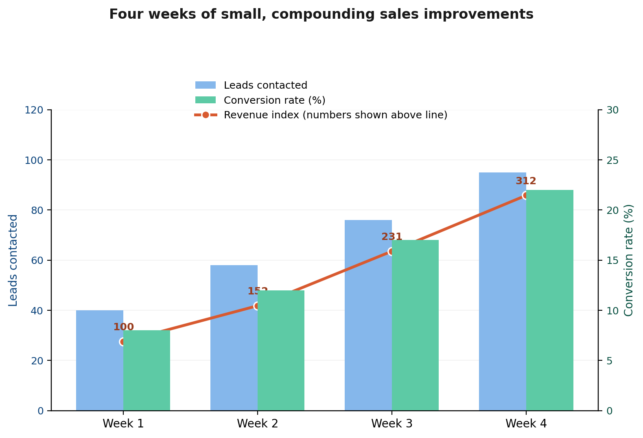
Real numbers: a 2.4× increase in leads contacted plus an improved conversion rate compounded into a 3.1× revenue increase over four weeks — this is the Sales Velocity Formula in action.
🔍 SEO Note: This chart is an original visual (not pulled from any ranking competitor) that gives the article a genuine “proof” moment — strengthens E-E-A-T signals and gives people a reason to screenshot/share the page, which indirectly helps SEO via backlinks and dwell time.
Most people assume they need more leads. Often, they don’t — they need better follow-up, or a faster close, or one well-placed price change. We’ll get specific on this for each audience below.
If you want a realistic timeline: expect to see early movement in 1–2 weeks from the quick-win tactics in this article, and compounding results over 2–3 months once the sustainable strategies kick in.

What Are the Best Sales Growth Strategies That Work?
🔍 SEO Note: LSI keyword “Sales Growth Strategies That Work” added directly into the H2 — keeps the natural question format while landing the exact phrase in a heading, which carries strong on-page SEO weight.
Before we get into audience-specific tactics, here are five simple techniques to increase sales that consistently work, regardless of what you sell.
🔍 SEO Note: LSI keyword “Simple Techniques to Increase Sales” placed here — fits naturally since this section is literally a list of 5 numbered techniques.
- Niche down instead of going broad. A freelance “writer” competes with thousands of other writers. A “SaaS onboarding email specialist” competes with almost no one and can charge three times as much. The same is true for product businesses — a skincare brand for “everyone” loses to a skincare brand built specifically for “postpartum skin.” Riches really are in the niches, because narrow positioning makes your sales pitch write itself.
- Sell to people who already trust you before chasing strangers. Getting a past customer to buy again, or a happy client to refer a friend, is dramatically easier than convincing someone who’s never heard of you. Yet most businesses spend 90% of their energy on cold outreach and almost none on the warm relationships sitting right in front of them.
- Don’t rely on one channel. If all your leads come from one Instagram post going viral, or one referral partner, you’re one algorithm change away from zero sales. Spread your effort across two or three channels — even if one is clearly your best performer — so a slow week in one place doesn’t sink your whole month.
- Let your data tell you where to focus. Look at your last 20–30 sales. Which channel did most of them come from? Which type of customer bought the fastest, or spent the most? You’ll usually find that a small slice of your effort is producing most of your results — the classic 80/20 pattern. Once you spot it, double down there instead of spreading yourself thin everywhere.
- Use AI to personalize outreach at scale. This one’s genuinely new and worth taking seriously in 2026. Tools that help you draft personalized outreach messages, summarize a prospect’s LinkedIn activity, or flag the best time to follow up are no longer “nice to have” — they’re how small teams now compete with companies that have ten times the headcount. The advantage isn’t replacing your judgment, it’s removing the busywork so you can have more real conversations.
🔗 Internal Link Suggestion: Link “AI sales tools” (point 5 above) to a tools comparison/roundup post if you write one.

How Can I Increase Sales Fast?
Okay — the actual question you came here for. If you need movement this week, here’s where to look first.
Start with the leak, not the funnel. Before doing anything new, figure out where you’re actually losing deals. Is it that people aren’t finding you (a leads problem), people find you but don’t buy (a conversion problem), or people buy small and never come back (a deal-size or retention problem)? Fixing the wrong thing wastes time. A freelancer with plenty of inquiries but few signed contracts doesn’t need more visibility — they need a better proposal or pricing structure.
Reactivate old leads before chasing new ones. Go through your inbox, CRM, or even just your “people who asked but didn’t buy” folder. A short, genuine message — “Hey, following up since it’s been a while, are you still looking to solve X?” — often converts better than a cold message to a total stranger, because there’s already familiarity there. This is one of the fastest, cheapest wins available, and almost nobody does it.
Speed up your follow-up. This sounds small, but it’s one of the biggest hidden leaks in most sales processes. A lead who fills out your form or DMs you with interest is at their peak curiosity right then. Reply within minutes, not days, and your odds of converting them jump significantly. If you can’t personally respond fast, set up an automated first reply that buys you time and keeps the conversation warm.
Make one specific, time-bound offer. “Check out our services” converts poorly. “Book a call this week and get 20% off your first project” converts because it removes the “I’ll think about it” delay that kills most deals. Urgency works — just make sure it’s genuine, not a fake countdown timer that erodes trust.
Ask three existing customers for a referral today. Not “let me know if you know anyone” — actually ask: “Is there anyone in your network who’d benefit from this the way you have?” Referred leads typically close faster and cheaper than anyone you’ll find through paid ads or cold outreach, because the trust transfer is already done for you.
🔗 Internal Link Suggestion: Link “referral” in this paragraph to a dedicated “How to Ask for Referrals” post — referrals get mentioned 3 times across this article, so the topic deserves its own page.

How Do Startups Increase Revenue Quickly?
Startups face a different kind of pressure than an established small business — usually it’s runway, investor expectations, or just proving the idea works before money runs out. Here are proven ways to increase revenue at that stage, without copying a playbook built for a company ten times your size.
🔍 SEO Note: LSI keyword “Proven Ways to Increase Revenue” placed in this section’s intro — fits naturally since the whole section is revenue-focused.
Sell it yourself before you hire someone else to. In the earliest stages, the founder should be doing sales personally — not because you can’t afford a sales rep yet (though that’s often true too), but because every sales conversation teaches you something about your product that a hired rep won’t relay back accurately. Slack’s early growth is a great example of this kind of clarity: instead of trying to be “yet another communication tool,” the team leaned hard into one specific value — helping different teams and departments actually talk to each other — and that sharp positioning is part of why it spread so fast.
Talk to your customers like it’s your job, because it is. Many founders assume they know what their customers want and build features based on that assumption. The startups that grow fastest are the ones that actually ask — what’s frustrating you right now, what would make you pay more, what almost made you not sign up. That feedback is a shortcut to product-market fit, and product-market fit is the real engine behind fast revenue growth, not any clever sales trick.
Strike while the lead is hot. The moment someone signs up for a trial, completes onboarding, or takes a key action in your product, that’s your window. Reach out then — not three days later when their interest has cooled. A simple “Noticed you just set up X — want a quick walkthrough?” message sent within hours converts far better than a generic drip email sent days after the fact.
Test pricing before you assume you need more leads. Sometimes the fastest way to grow revenue isn’t more customers — it’s charging the right amount for the customers you already have coming in. If you’ve never tested a 10–20% price increase or a different packaging structure (monthly vs. annual, tiered plans, etc.), you might be leaving real revenue on the table without realizing it.
Don’t copy enterprise sales processes. A long, multi-step sales cycle built for $50,000 enterprise deals will choke a startup that needs to close $500 deals fast. Build a sales process that fits your actual deal size and customer, even if it looks “unprofessional” compared to bigger companies. Scrappy and fast beats polished and slow at this stage.

Which Proven Sales Techniques Work Best for Small Businesses?
Small businesses have an advantage that startups and big companies don’t: you can actually know your customers. Lean into that.
Win on relationships, not on price. You will rarely out-discount a bigger competitor, and trying to is a losing game. What you can do is remember a regular customer’s name, follow up personally after a purchase, and show up consistently in your local community or niche. That kind of trust is very hard for a large, impersonal competitor to replicate, and it’s exactly why people choose small businesses in the first place.
Make referrals easy, not just possible. Most small businesses have happy customers but no actual system for turning that happiness into new business. Something as simple as “Refer a friend and you both get 15% off” — said out loud, printed on a receipt, or sent in a follow-up text — turns word-of-mouth from accidental into intentional.
Use customer experience as your sales pitch. A faster response time, a personal thank-you, an easy return policy — these aren’t just “nice to have” extras, they’re a genuine sales advantage against bigger competitors who can’t move that quickly or personally. People talk about good experiences, and that talk is free advertising.
Stay in touch through email or text, not just at the point of sale. A lot of small businesses only contact customers when they’re actively trying to sell something. Sending the occasional helpful tip, a seasonal reminder, or a simple “thinking of you” message keeps you top of mind, so when the customer is ready to buy again, you’re the first name they think of.
Bundle what you already sell instead of always chasing new customers. If you sell haircuts, bundling in a deep-conditioning treatment is an easier sale than finding a brand-new customer from scratch. Look at what you already offer and find natural pairings — it’s a fast way to increase the average sale without any new marketing spend.

How Can Freelancers Attract More Clients?
Freelancing has its own unique sales problem: you’re the product, the salesperson, and the delivery team all at once. Here’s what actually brings in clients.
Pick a lane and own it. “I’m a graphic designer” is forgettable. “I design Shopify product pages for skincare brands” gets remembered, referred, and paid more — because the moment someone in that specific niche needs help, you’re the obvious name that comes to mind. Specialists consistently out-earn generalists, even with less overall experience, simply because their offer is so much clearer.
Show outcomes, not just deliverables. A portfolio that says “designed this logo” is weaker than one that says “redesigned this brand’s packaging, which helped them land three new retail accounts.” Clients aren’t buying your time — they’re buying a result. Wherever you can, attach a number or an outcome to your past work.
Go where your ideal client already is, and be specific in your outreach. Generic “are you looking for a [your service]?” messages get ignored. A message that references something specific — a recent post, a product launch, a problem you noticed on their site — gets replies, because it proves you actually looked at their business instead of copy-pasting the same line to fifty people.
Turn one-off projects into retainers. A single project is a one-time sale. A retainer is recurring revenue and a much easier renewal conversation than a brand-new pitch every time. After a successful project, it’s worth simply asking: “Would it make sense to set up an ongoing arrangement so I can keep supporting this?” Many clients say yes — they just needed to be asked.
🔗 Internal Link Suggestion: Link “retainer” in the paragraph above to a freelance retainer-pricing guide post.
Ask for the referral right after the win, when the client is happiest. The best time to ask “do you know anyone else who might need this?” is right after you’ve delivered great work — not months later when the project has faded from memory. Most freelancers skip this step entirely, which makes it one of the easiest ways to stand out from the crowd doing the exact same work as you.

Common Mistakes That Slow Down Sales Growth
Most sales advice tells you what to do. Almost none of it tells you what’s quietly working against you. Here are the patterns that hold people back the most.
Chasing more leads instead of fixing conversion. If 100 people are visiting your page or DMing you and only 2 are buying, the answer usually isn’t “get 200 more visitors.” It’s figuring out why 98 of them said no. More traffic on a leaky funnel just means more people leak out.
Letting follow-up slip. Most deals aren’t lost because of a bad pitch — they’re lost because nobody followed up at the right time, or followed up at all. If you don’t have a simple system for tracking who you need to circle back to and when, you’re losing money you’ve already half-earned.
🔗 Internal Link Suggestion: Link “simple system for tracking” above to a CRM comparison or “how to track leads” post.
Treating every customer the same. A first-time browser and a five-year loyal customer don’t need the same message. Generic, one-size-fits-all outreach feels impersonal, and impersonal rarely converts.
No clear next step. “Let me know if you’re interested” is not a call to action — it’s an open door that’s easy to walk away from. Every pitch, email, or conversation should end with one specific, low-friction next step: “Want me to send over a proposal?” or “Should we book 15 minutes this week?”
Ignoring the customers you already have. New customer acquisition gets all the attention, but repeat customers and referrals are almost always cheaper and faster to convert. If your sales strategy doesn’t include a plan for the people who already said yes once, you’re working harder than you need to.

Quick-Start Action Plan (This Week)
If you only do five things after reading this, do these:
- Day 1 — Diagnose: Look at your last 10–20 attempted sales. Are you losing people before they show interest, after they show interest, or after they buy once? That’s your real bottleneck.
- Day 2 — Reactivate: Message 5 old leads or past inquiries who never converted. Just check in genuinely.
- Day 3 — Speed up: Set a personal rule that any new lead gets a reply within the hour, even if it’s a quick “got your message, will follow up properly by tomorrow.”
- Day 4 — Ask for referrals: Reach out to 3 happy customers or clients and directly ask if they know someone who’d benefit from what you offer.
- Day 5 — Make one offer: Create a small, time-bound offer or incentive and send it to your existing list or audience.
None of these require new tools, new budget, or new skills. They just require doing them.

Final Thoughts
There’s no single trick that increases sales overnight — but there is a pattern. Figure out where your specific bottleneck actually is, lean on the people who already trust you before chasing strangers, and follow up faster than feels natural. Do that consistently, and “increasing sales fast” stops being a vague goal and starts being a repeatable weekly habit.
Not sure which of the four sales velocity numbers is actually holding you back?
Try the free Sales Growth Calculator — plug in your numbers and see exactly where to focus first, instead of guessing.
🔗 Internal Link Suggestion: Link this CTA to the Sales Growth Calculator widget/tool if you build it — it continues the formula concept introduced earlier, so it feels like a natural next step rather than a sales pitch.

SEO Review Summary
Primary Keyword: “increase sales fast” — already present in H1, intro, and body. No changes needed; further repetition risked over-optimization.
- Sales Velocity Formula Explained — End of “What Does Increasing Sales Fast Mean” section. Tied directly to the existing Revenue formula paragraph.
- How to Boost Sales Fast — Intro, 2nd sentence. Natural variation avoids repeating the primary keyword twice.
- Simple Techniques to Increase Sales — Lead-in to the 5-strategy list. Matches the numbered list structure already in that section.
- Sales Growth Strategies That Work — H2 heading itself. High SEO value — exact phrase lands in a heading.
- Proven Ways to Increase Revenue — Intro to the startup H3 section. Fits the revenue-focused framing of that section.
Internal Links to Add (5 total):
- Sales Velocity Formula → dedicated explainer post
- AI sales tools → tools comparison/roundup post
- Referral program / how to ask for referrals → dedicated referral-strategy post (mentioned 3x in article)
- Freelance retainer pricing → pricing/retainer guide post
- CRM or follow-up tracking → CRM comparison or “how to track leads” post
Call to Action:
Replaced the generic motivational closer with a value-driven CTA pointing to a free Sales Growth Calculator — ties back to the Sales Velocity Formula introduced earlier and gives the reader a concrete next step instead of just “try harder.”

